**“Weather Assistant”**

instructions for use

**Step 1: Double click to open the program**

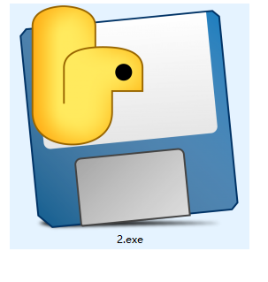

**Step 2: Click on Open Photo, select the image and open it**

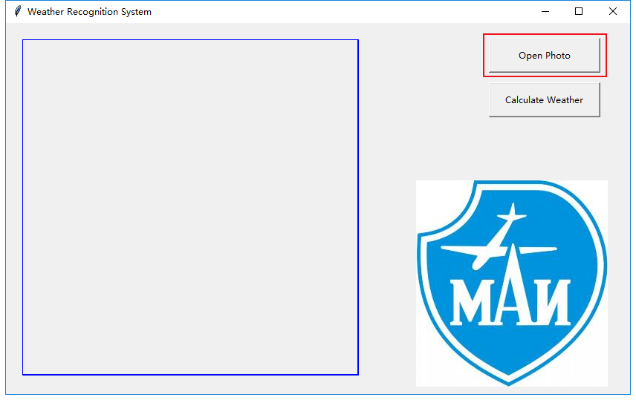

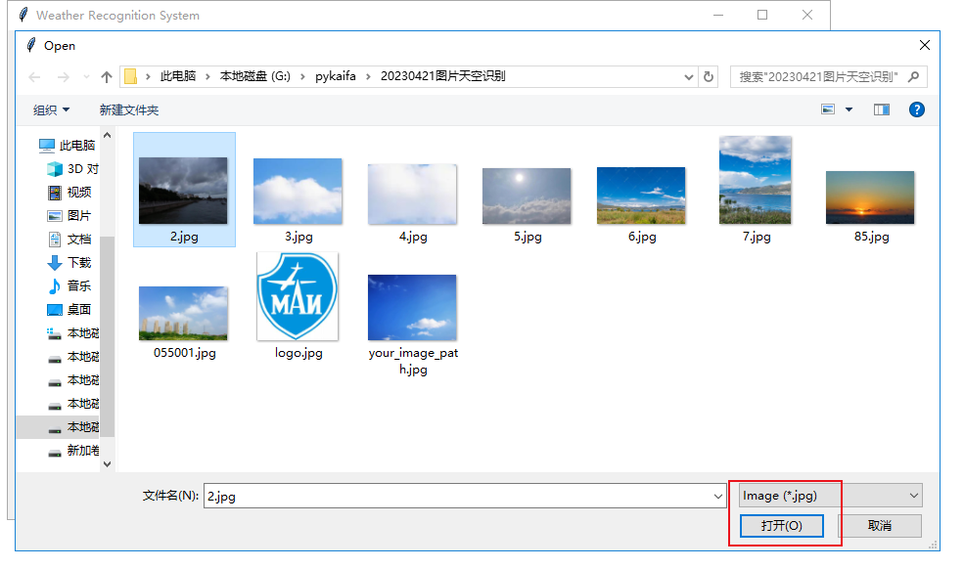

**Step 3:** **Click on Calculate Weather to identify the weather**

